The Twenty-Sixth Annual

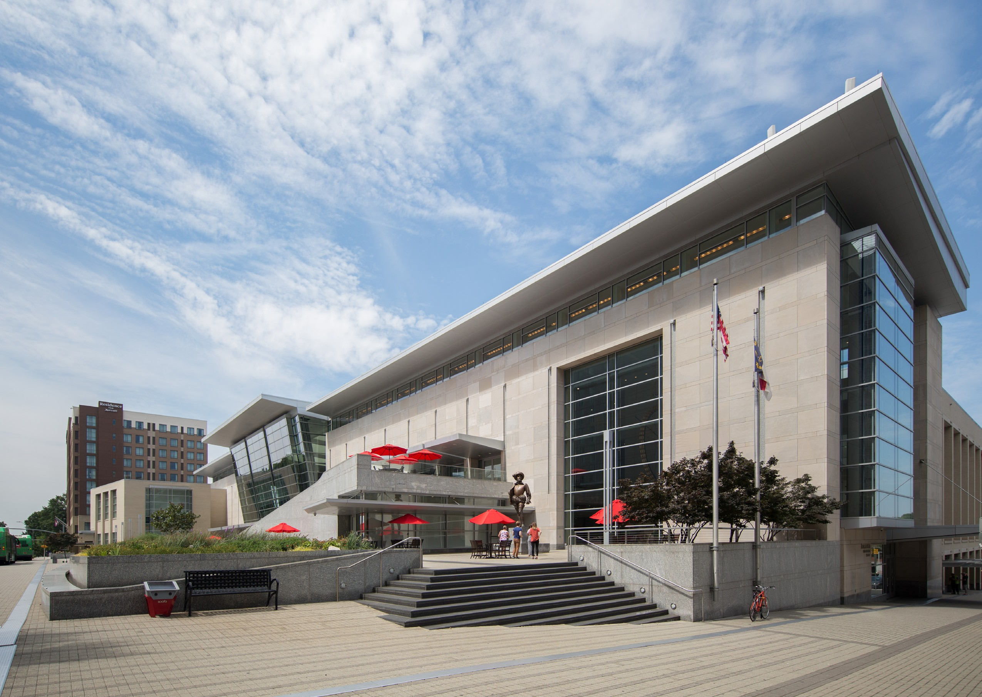

North Carolina Workers’ Compensation Educational Conference

*Photo credit VisitRaleigh.com and Photographer Brian Strickland*

**Wednesday - Friday October 6-8, 2021**

**Raleigh Convention Center** 500 South Salisbury Street Raleigh, North Carolina 27601

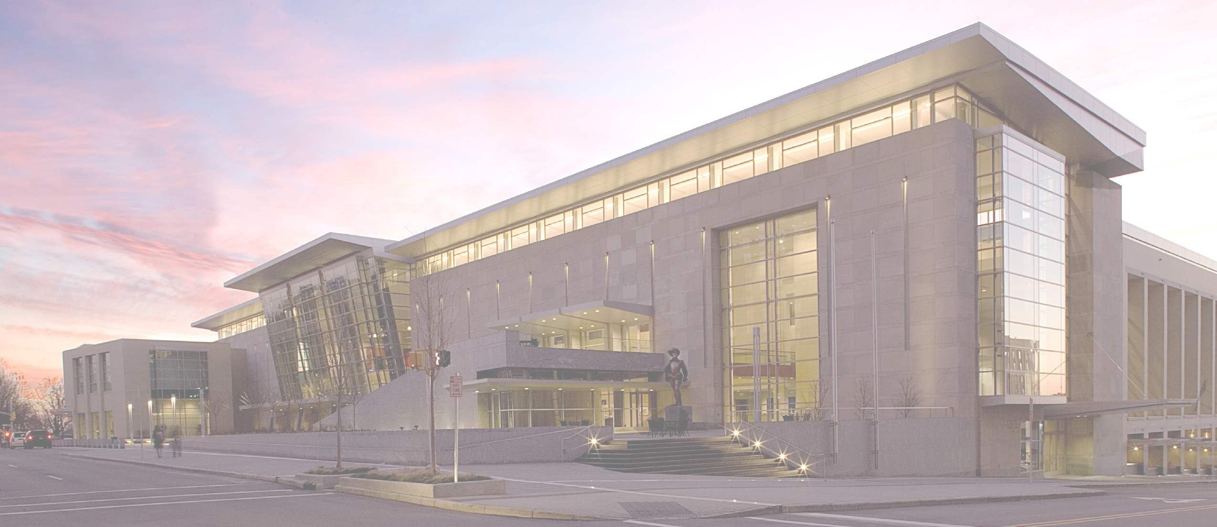

The 26th Annual North Carolina Workers’ Compensation Educational Conference will be held October 6 -8, 2021, at the Raleigh Convention Center. To protect the safety of in-person attendees, the Conference will carefully follow all public health protocols.

The program is organized by the North Carolina Industrial Commission. The goal of this conference is to educate those who participate in the North Carolina workers’ compensation system regarding current rules, procedures, policies and forms and to provide an opportunity for dialogue among these participants. The presenters include the Chair and Section Heads of the Industrial Commission, plaintiff ’s and defense attorneys, physicians, medical and vocational rehabilitation specialists and mediators. Breakout sessions will be utilized to discuss certain topics in greater detail, while other topics will be presented from a more general perspective.

## Who Should Attend?

All employers, insurance adjusters, self-insurers, third-party administrators, safety & human resource managers, plaintiff ’s and defense attorneys, paralegals, health care providers, mediators and medical and vocational rehabilitation providers are encouraged to attend. Anyone with a professional interest in the workers’ compensation system in North Carolina will receive valuable information at the conference.

## Continuing Education Credits

Participants may be eligible for up to 12 hours of continuing education credits. Application will be made for credits in the following occupations: attorneys (CLE), paralegals (CPE), insurance adjusters (CE credit), human resources professionals (SHRM), and rehabilitation providers (CE for CRC, CDMS and CCM). COHNs, CRRNs and any other discipline will be provided, upon request, with a certificate of completion for credit submission. For adjusters, the conference sessions are grouped into three courses. **Adjusters must complete all sessions in each course to receive credits for that course.**

Insurance adjusters also should be aware that the North Carolina Department of Insurance does not award credit to non-resident adjusters with North Carolina licenses unless domiciled in North Carolina as an adjuster. For general information concerning licensing and CE requirements for adjusters in North Carolina, please contact the North Carolina Department of Insurance at (919) 807-6800.

## Materials

Attendees will be able to download the materials via internet prior to the conference. Please look for the link in an email announcement from [IWCF@bellsouth.net](mailto:IWCF@bellsouth.net) when the materials are available. Please provide an accurate and legible email address when you register to ensure receipt of the instructions. Also, please add [IWCF@bellsouth.net](mailto:IWCF@bellsouth.net) to your email safe sender list as a trusted contact.

## Hotel Information

**The host hotel for our conference is:**

### THE RALEIGH MARRIOTT CITY CENTER

501 Fayetteville Street, Raleigh, NC 27601 • Across the street from the Convention Center

#### Conference Rate: $205.00/night • Rate Cut-Off Date: September 7, 2021

The conference group rate will not be available if the room blocks become full prior to the cut-off date; make your reservations early. Click here to book your group rate for North Carolina Workers Compensation Conference. Or call 888-236-2427 (hold times may be lengthy).

## Raleigh Convention Center Parking Information

Please visit the Convention Center’s website at [www.raleighconvention.com/directions](http://www.raleighconvention.com/directions) for detailed driving directions to the two parking garages you should use for our conference (the Performing Arts Deck and the Marriott Deck, both located on the corner of Lenoir and Salisbury Streets). Please check back prior to your arrival for the cost, availability, and instructions for discount event parking for conference attendees. Marriott guests must self-park rather than valet-park to receive the event parking rate. Exhibitors should go to the underground parking garage of the Convention Center located on the corner of Lenoir and Dawson Streets to unload booth materials and equipment; a garage attendant will provide unloading instructions and parking directions upon arrival.

*Photo credit VisitRaleigh.com and Photographer Brian Gassell*

# TENTATIVE TOPICS

Social Media: Legal and Ethical Considerations Treating the Patient and Maximizing Return to Work Potential

Medicare Set Asides, Other Medical Expenses, and Future Medical Considerations Maximizing Post-Injury Earning Capacity

Rehabilitation Case Manager Ethics Recent Developments in Mediation

Compassion Fatigue: The Price We Pay as Professional Problem Solvers Ethical Considerations for Adjusters and Attorneys

A View from the Chair

Practical Tips for Successful Appeals to the Full Commission Exploring Non-Pharmacological, Multi-Disciplinary Pain Treatment Options

Implicit Bias in Workers’ Compensation Cases

Update on Recent Rulemaking and Executive Secretary’s Office Deputy Commissioner Section Updates and Hot Topics Update from the Clerk’s Office and Claims Administration The Case Management System

Case Law Update

# SCHEDULE OF SESSIONS

### WEDNESDAY, OCTOBER 6, 2021

1:00 – 1:15 PM Opening Remarks

1:15 – 3:15 PM General Sessions

3:15 – 3:45 PM *Break – Visit Exhibit Hall*

3:45 – 5:15 PM General Sessions

5:15 – 6:15 PM *Adjourn/Reception Begins*

### FRIDAY, OCTOBER 8, 2021

8:00 AM Continental Breakfast 8:30 – 9:45 AM General Sessions

9:45 – 10:15 AM *Break – Visit Exhibit Hall*

10:15 – 12:30 PM General Sessions

12:30 PM *Adjourn*



8:00 AM

**THURSDAY, OCTOBER 7, 2021**

*Continental Breakfast*

8:30 – 9:30 AM General Sessions

9:30 – 10:00 AM *Break – Visit Exhibit Hall*

10:00 – 12:00 PM **Concurrent Breakout Sessions (Choose I of II)**

12:00 – 1:30 PM *Luncheon (included)*

1:30 – 2:30 PM **Concurrent Breakout Sessions (Choose I of II)**

2:30 – 3:00 PM *Break – Visit Exhibit Hall*

3:00 – 4:00 PM **Concurrent Breakout Sessions (Choose I of II)**

4:00 PM *Adjourn*

***For further information contact the IWCF office at Tel: (386) 677-0041; Fax: (386) 677-0155; Email:*** [***IWCF@bellsouth.net***](mailto:IWCF@bellsouth.net) ***or***

***International Workers’ Compensation Foundation, 570 Memorial Circle, Suite 320, Ormond Beach, FL 32174.***

***For further information contact the IWCF at Tel: (386) 677-0041; Fax: (386) 677-0155; Email:*** [***IW***](mailto:IWCF@bellsouth.net)[***CF@bellsouth.net***](mailto:CF@bellsouth.net) ***International Workers’ Compensation Foundation, 570 Memorial Circle, Suite 320, Ormond Beach, FL 32174.***

Net proceeds from this event, if any, go to the International Workers’ Compensation Foundation (FEIN# 35-1737364), a non-profit orgnanization, to further its work in workers’ compensation education and outreach.

Registration Fees: $300.00 per person paid on or before July 31, 2021

$325.00 per person paid on or before August 31, 2021

$375.00 per person paid after August 31, 2021

*Registration Fees include sessions, access to materials, reception, luncheon, and 2 breakfasts*

Two registration options are available.

1. **Payment by Credit Card** (MasterCard, VISA or American Express) - go to [www.iwcf.us/schedule/](http://www.iwcf.us/schedule/) and click on link under NORTH CAROLINA.
2. **Payment by Check** Complete, copy and return this form for each attendee, along with a check made payable to the IWCF (International Workers’ Compensation Foundation, Inc.), and mail to IWCF, 570 Memorial Circle, Suite 320, Ormond Beach, FL 32174.

Name: �������������������������������������������������������������������������������������������������� Business Name: ��������������������������������������������������������Title: ������������������������������ Address: ������������������������������������������������������������������������������������������������� City:������������������������������������������������������������������State: ��������� Zip: ���������������� Telephone: ����������������������������������������������������������� Fax: �������������������������������� Email: ��������������������������������������������������������������������������������������������������

Area of Practice: Employer Employee Health & Safety Specialist Insurer TPA Attorney Mediator Paralegal Occup. Health Nurse Health Care Provider Medical Rehab Specialist Vocational Rehab Specialist Human Resources Professional Other:���������������������������������������������������������������������

**CONTINUING EDUCATION CREDITS** - Application will be made for up to 12 hours of credit for Attorney CLE, Paralegal CPE, Adjuster CE, SHRM CE, Rehabilitation CRC/CDMS/CCM credits; and COHN, CRRN contact hours. Any other discipline will be provided, upon request, with a certificate of completion. Please note special Department of Insurance rules for adjusters.

**Please indicate the CE credits you will be seeking:**

NC Attorney - Bar #: �������������������������������� NC Adjuster - NPN #: ��������������������������������

����� Paralegal ����� SHRM ����� CCM ����� CRC �����CDMS �����OHN

**LODGING** - The host hotel is: THE RALEIGH MARRIOTT CITY CENTER - 501 Fayetteville Street, Raleigh, NC 27601 • Across the street from the Raleigh Convention Center; Conference Rate: $205.00/night • Rate cut-off September 7, 2021. The conference group rate will not be available if the room block becomes full prior to the cut-off date; make your reservations early. Click here to **book your group rate for North Carolina Workers Compensation Conference.** Or call 888-236-2427 (hold times may be lengthy).

**MATERIALS** - Download the materials via internet prior to the conference. Please look for the link in an email announcement when the materials are available. Please be sure to provide an accurate and legible email address when you register to ensure receipt of the instructions.

**DRESS CODE** - Casual clothing is appropriate for all events.

**CANCELLATION REFUND POLICY** - Cancellation of pre-registration must be made before 5:00 p.m. on September 24, 2021. Substitution of attendee is recommended in lieu of cancellation after that date. The full registration fee will be forfeited if you fail to attend or cancel timely.

**SPECIAL NEEDS** - Individuals attending the conference who may need auxiliary aids or special services are requested to provide notice of their needs in writing no later than 10 working days before the conference so that appropriate arrangements can be made.

# ATTENTION EXHIBITORS

Fee of $900 includes two (2) complimentary registrations for exhibitor representatives. A separate registration form should be completed for each additional registrant.

Space is offered on a first come, first served basis and will only be reserved upon our receipt of your registration. Register online (credit cards only). Or send an advance copy of this form and your 1st three choices of booth location by fax to (386) 677-0155 or email to [iwcf@bellsouth.net.](mailto:iwcf@bellsouth.net) For additional information regarding exhibit area, contact the IWCF at (386) 677-0041. Booth set-up will be in the exhibitor area on Wed., Oct. 6th, 10 A.M. - 1 P.M. Tear down will be on Fri., Oct. 8th, 12:50 P.M.

The reception, continental breakfasts and refreshment breaks will be held in the Exhibi- tion Ballroom. Registration fee includes one 8’x10’ booth or 6’ draped table and two chairs, identification sign, registration for two representatives and twenty-four hour security. Full fee forfeiture if unable to attend.

**Kids’ Chance of North Carolina** (www.kidschancenc.org) invites all vendors to donate an item to be auctioned during the Wednesday reception. All donations are tax deductible and donors will be recognized. For more information, please contact:

**Marty Baier, Silent Auction Chair**

(919) 622-5995 or email: [marty@baierinvestigations.com](mailto:marty@baierinvestigations.com)

**Paul Sequin, Executive Director - Kids’ Chance**

(800) 246-8599 ext 116 or email: [kidschancenc@gmail.com](mailto:kidschancenc@gmail.com)

### EXHIBITOR INSURANCE HOLD/HARMLESS CLAUSE

Exhibitor assumes entire responsibility and hereby agrees to protect, indemnify, defend, save, and hold harmless the International Workers’ Compensation Foundation (IWCF), its employees and agents, and Chelsea Place Meetings and its employees and agents, against all claims, losses and damages to persons or property, governmental charges or fines and attorney fees arising out of its exhibits excluding any such liability caused by the sole negligence or concurrent comparative negligence of Chelsea Place Meetings and its employees and agents, as well as the IWCF, its members, employees and agents.

In addition, exhibitor acknowledges that Chelsea Place Meetings and the IWCF do not maintain insurance covering exhibitors’ property or potential liabilities and that it is the sole responsibility of the exhibitor to obtain insurance covering such losses by exhibitor. Exhibitor shall obtain and keep in force during the exhibit period policies of comprehen- sive general liability insurance and contractual liability insurance and specifically refer- ring to contractual liability set forth in the foregoing paragraphs hereof, in an amount not less than $1,000,000 combined single limit for personal injury and property dam- age. Chelsea Place Meetings and the IWCF shall be included in such policies as addition- ally named insureds for this convention only.

**AUTHORIZED**

**SIGNATURE: DATE:**

# SPONSORSHIP OPPORTUNITY

You are invited to register as a sponsor for the Twenty Sixth Annual North Carolina Workers’ Compensation Educational Conference. The following sponsorship levels are available:

**Gold: $1,000 Contribution**

* Complimentary Attendee Registration.
* Organization name and contact information will appear in conference program.
* Organization name will appear on a large“Thank You Sponsor” sign in exhibit area.

**Silver: $500 Contribution**

* Organization name will appear on a large“Thank You Sponsor” sign in exhibit area.

**CHECK CATEGORY WHICH APPLIES: EXHIBITOR**

**SPONSORSHIP** Gold Silver

Company Name: Specialty: Contact Person: Title: Address:

City: State Zip: Phone: Fax: Email Address:

**EXHIBITORS & GOLD SPONSORS ONLY**

Comp. Registrant #1:

*Name & Title*

Email:

**EXHIBITORS ONLY**

Comp. Registrant #2:

*Name & Title*

Email:

**Two registrations are available:**

1. **Payment by Credit Card** (MasterCard, VISA, or American Express) - go to [www.iwcf.us/schedule](http://www.iwcf.us/schedule) and click on link under NORTH CAROLINA ***(Credit Cards Only)***
2. **Payment by Check** - Complete, copy, and return this form along with a check made payable to IWCF (International Workers’ Compensation Foundation, Inc.) and mail to IWCF, 570 Memorial Circle, Suite 320, Ormond Beach, FL 32174.

**For additional information contact the IWCF at: Phone (386) 677-0041 • Fax (386) 677-0155 •** [**iwc**](mailto:iwcf@bellsouth.net)[**f@bellsouth.net**](mailto:f@bellsouth.net)

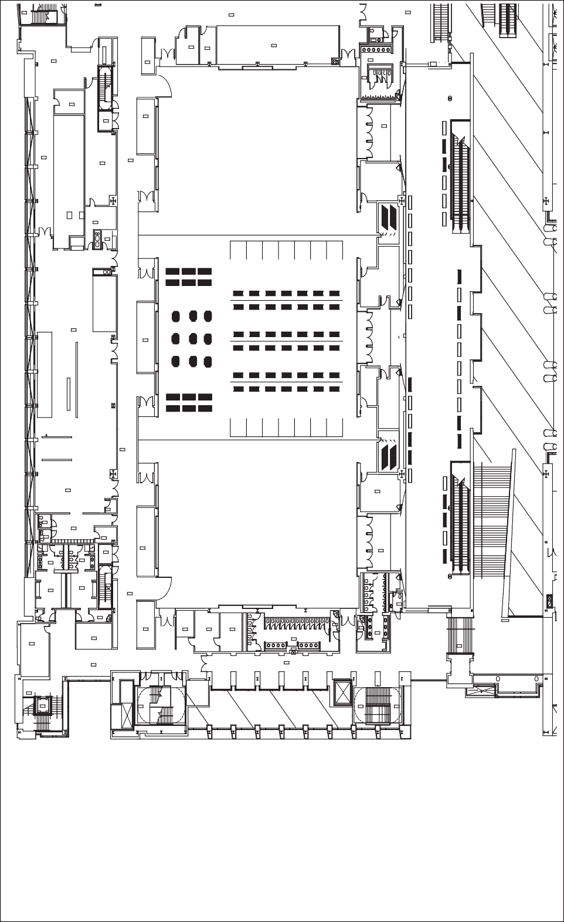

STAIR

13

BACK OF HOUSE CORRIDOR

424

CORRIDOR

457

EC

FEC

TOILET

455

STAIR

361

ELEC. ROOM 450

TELE. ROOM

451

STORAGE

452

STORAGE

COMMISARY

438

STORAGE

445

MEN'S TOILET 456

MEN'S TOILET 456

LIQUOR STORAGE

439

F.S. ALCOVE 444

AREA WAY

443

PREFUNCTION

410A

COMMISARY

438

BACK OF HOUSE

DRY CORRIDOR

STORAGE 424

442

FEC

DRY STORAGE 440

FEB

CHEF OFFICE

441

KITCHEN

435

STORAGE

437

FEC

FEB

BACK OF HOUSE CORRIDOR

424

KITCHEN

435

TELE

409

JANITOR'S CLOSET 436

TOILET

432

F.S. BREAK ROOM/ LOCKERS

431

TOILET

433

UNIFORMS

434

F.S. ALCOVE

429

AREA WAY

430

PREFUNCTION

410C

MEN'S TOILET

425A

WOMEN'S TOILET 427A

MEN'S DRESSING ROOM

425

WOMEN'S DRESSING ROOM

427

STAIR

4-20

BACK OF HOUSE CORRIDOR

424

TOILET

411

JANITOR'S CLOSET 426

JANITOR'S CLOSET 428

STORAGE

JANITOR'S CLOSET 417

STORAGE

422

STORAGE

421

ELEC.

420

TELE

419

JANITOR'S CLOSET 415

MEN'S TOILET 414

STORAGE

423

WOMEN'S TOILET 416

STORAGE

458

STAIR

412

BACK OF HOUSE CORRIDOR

424

PUBLIC BALCONY 418

DW-8

STAIR

7

ELEVATOR

8

STAIR

19

STAIR

18

STAIR

18

DW-8



***For further information contact the IWCF office at Tel: (386) 677-0041; Fax: (386) 677-0155; Email:*** [***IWCF@bellsouth.net***](mailto:IWCF@bellsouth.net) ***or International Workers’ Compensation Foundation, 570 Memorial Circle, Suite 320, Ormond Beach, FL 32174.***

***booth dimenSionS***

***1-7; 50-56: 10’ wide / 8’ deep***

***8-49; 57-90: 6’ wide / 4’ deep (recommend using table top dis- plays for booths 8-49 and 57-90)***

***pleaSe provide uS with your top three choiceS oF location when you Send in your regiStration Form:***

Banquet Seating

Buffet Tables

Buffet Tables

50

51

52

49

36 35

22 21

8

7

6

5

Meeting Room

Meeting Room

48

37 34

23 20

9

**Choice #1**

**Choice #2**

**Choice #3**

47

38 33

24 19

10

53

54

55

56

46

39 32

25 18

11

4

3

2

1

45

40 31

26 17

12

44

41 30

27 16

13

43

42 29

28 15

14

Your booth location will be confirmed promptly.

57

58 59 60

61

62

63

64

65

66 67 68 69

PLEASE SEND TO:

IWCF

[iwcf@bellsouth.net](mailto:iwcf@bellsouth.net) or

Fax (386) 677-0155

90 89 88 87 86

75 74 73 72 71 70

85 84

83

2

8 80

79 78

77

76